# How To Use

Quick Access

My Project

My Tasks

My Contributions

My Devices

Create new project

Settings

First you need an account. Please go to the [siliconsociety.org](http://www.siliconsociety.org) Then click on the Sign Up button

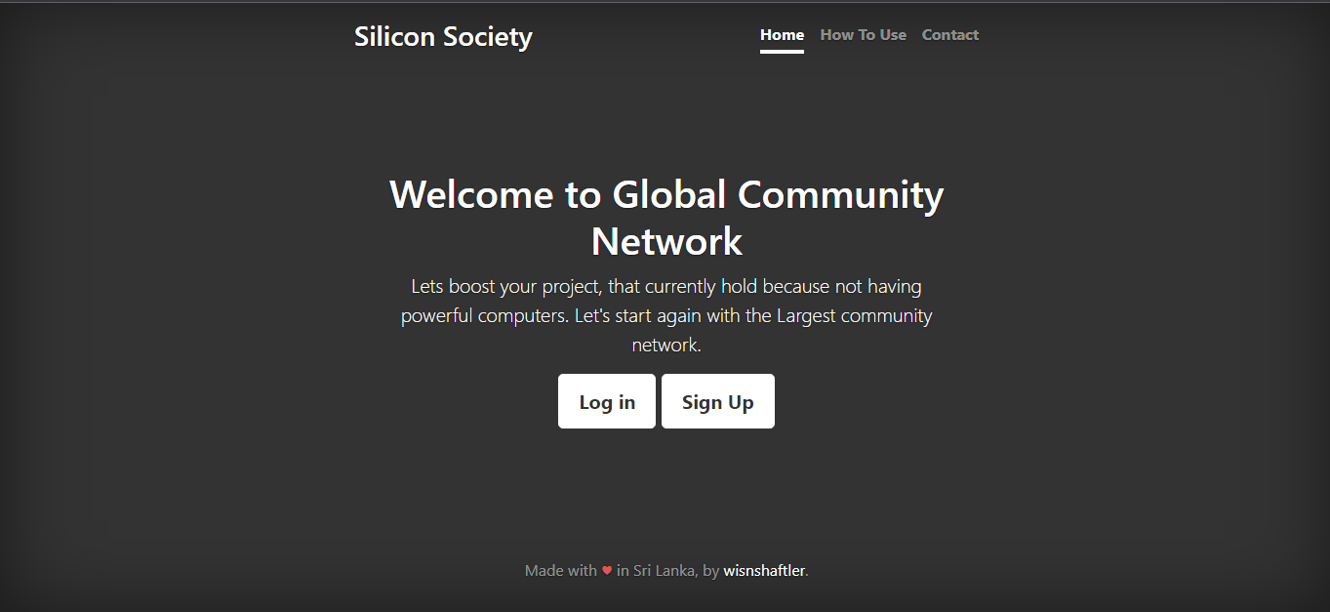

Fill the all the fields and click on the Create Account button. When you click on the Create Account button, you accept all of the terms and conditions.

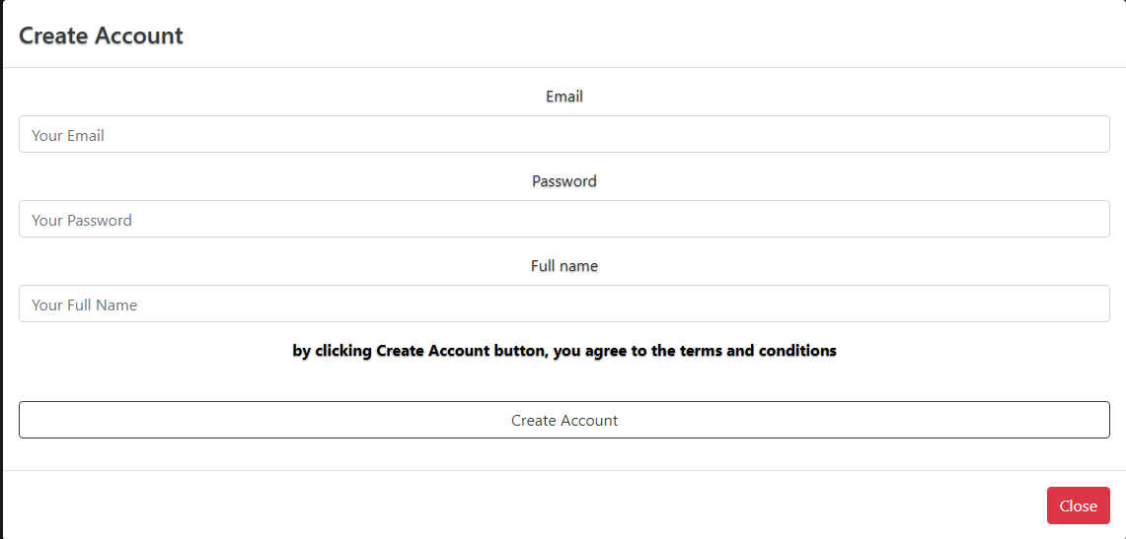

Then go to your email account and click on the confirmation email that we sent.

That’s all. Now click on the login button and sign in to the platform.

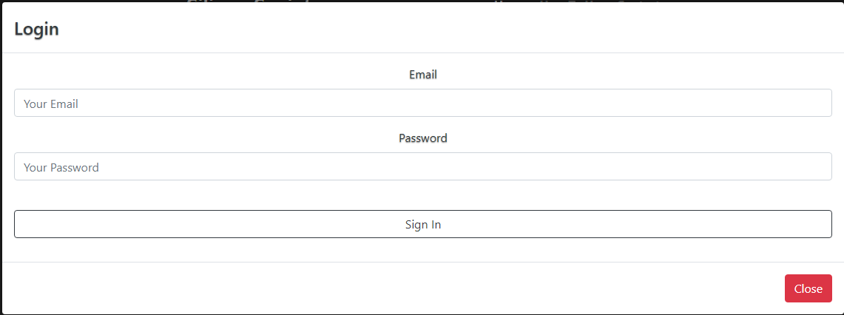

After sign in to the system you are in your profile page. In this page you can manage all your projects, contributions, device management and account password changing. In the bottom of the page, you can find the navigation panel. (Yes!!! In this website you don’t have a navigation bar on top. Why? Because why do we follow that old kind of rule here? We were born to change the system) In this navigation panel you can find in the left bottom corner API documentation URL. Next to it you can find the How To Use section (That’s the location that you are reading now.) and next to it you can find the Log Out button. In the right side of the navigation bar, you can find how much you contributed and total you created. In here (the client panel) you don’t want to browse many web pages. All your requirements are in this page. You need to click on the links (The blue color texts) and it will show what you can do. Also, there is a quick view of the capabilities. Here you can find 6 main operations that you can do. Those are,

1. My Projects
2. My Tasks
3. My Contributions
4. My Devices
5. Create New Project
6. Settings

My Projects – In here you can find and manage your own (that means you created) projects. You can deactivate them, can view progress and also you can add new tasks to projects. Now check one by one how to use this.

## My Project

By clicking on the My Project link, you can expand the project visualization area. Here you can find your projects. Every project has a View Project button. Click on that button you can view your selected project and manage the project.

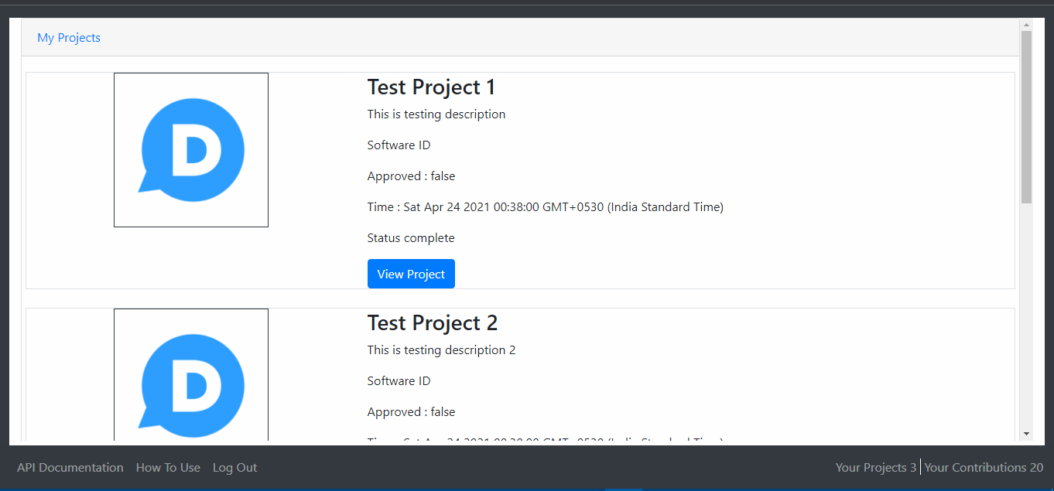

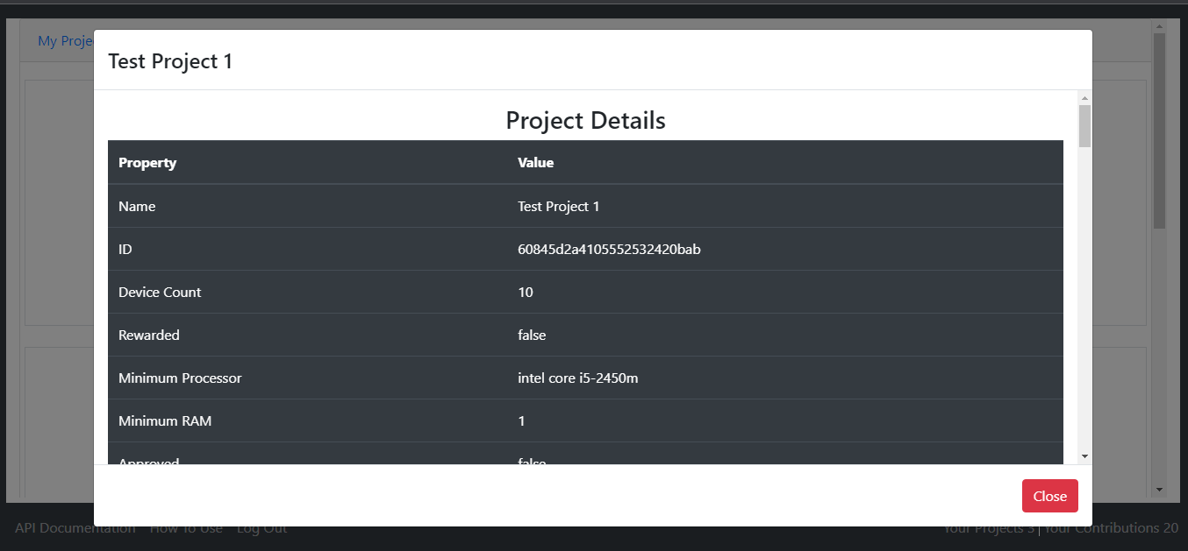

Scrolling down you can find project tasks. Here only shows the last 15 projects. And show how many tasks you have in this selected project. You can download all the task data.

Also, you can add new tasks to this selected project.

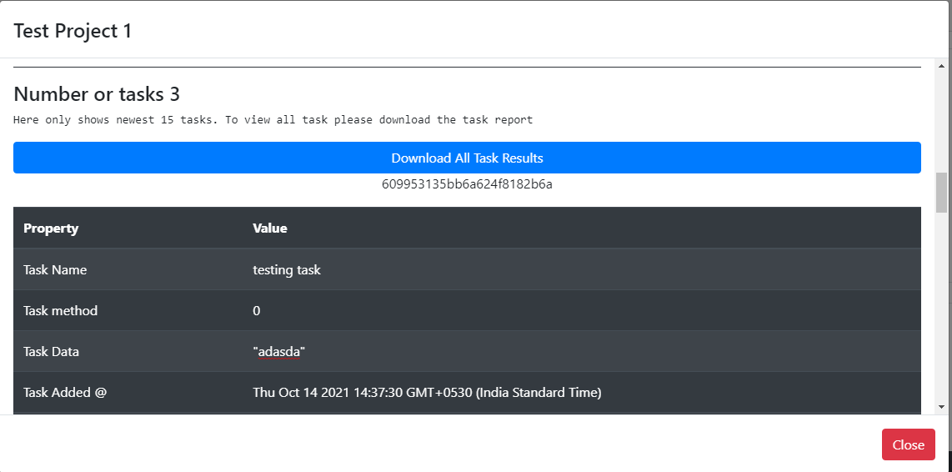

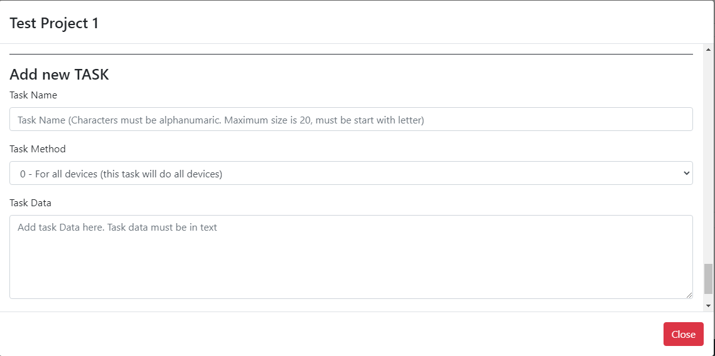

## My Tasks

In this section you can search your task by its name or ID. You can change the task name and you can suspend the task if you need.

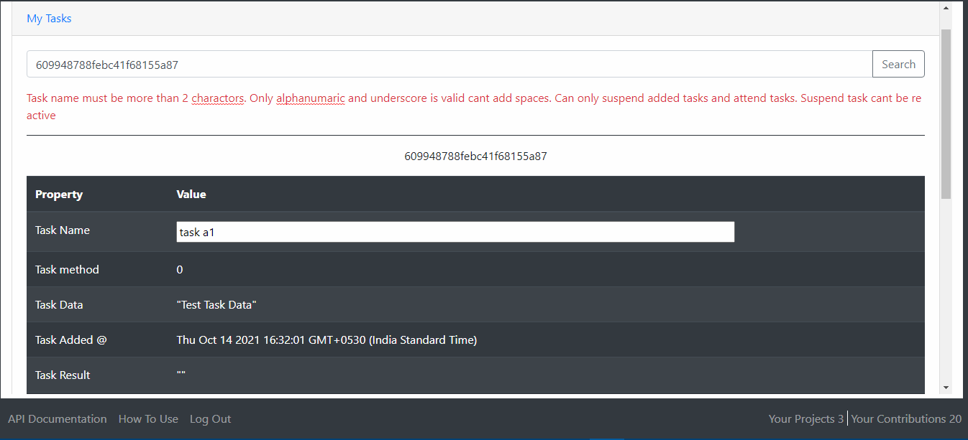

## My Contributions

In this section you can see what your contributions are. All of your device contributed tasks are shown here. Also, you can download task data if you need.

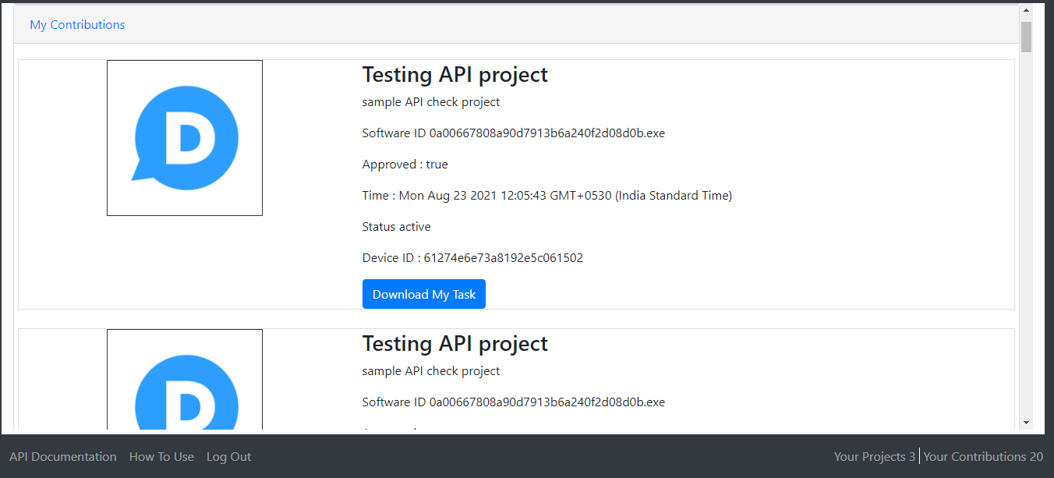

## My Devices

In this section, you can find your devices that you connected with this platform. Here you can activate or deactivate the device. When deactivated, the device no longer can contribute or participate in the project process.

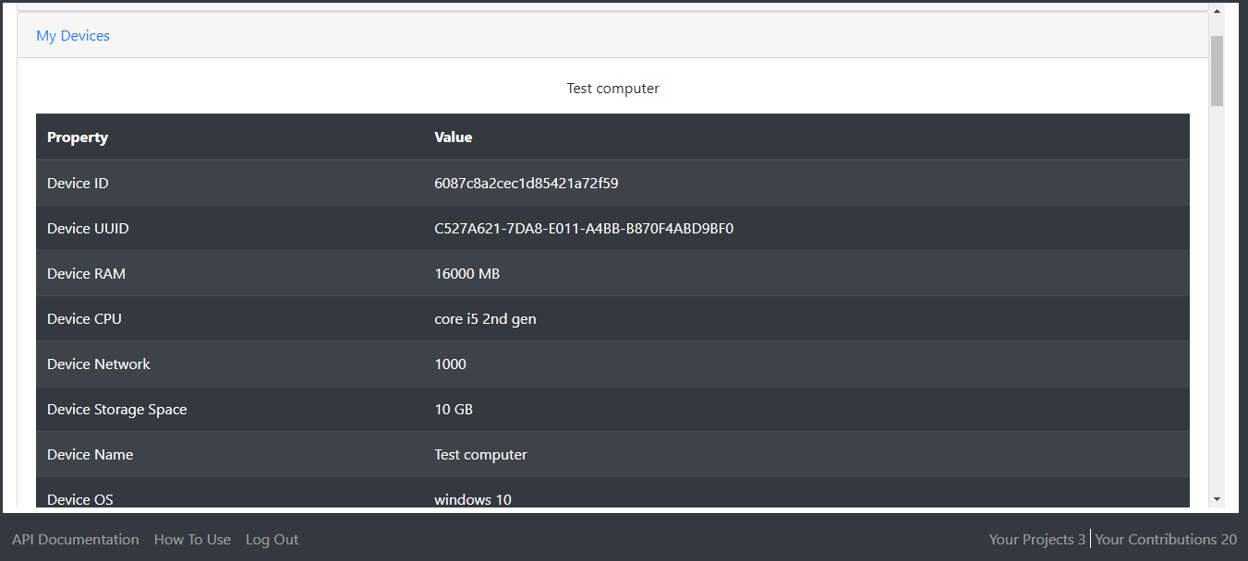

## Create new project

In this section, you can create a new project and add the client software you created project earlier.

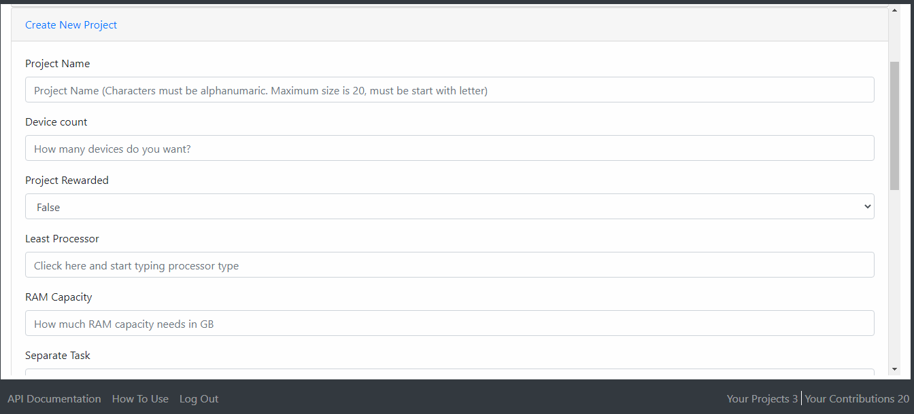

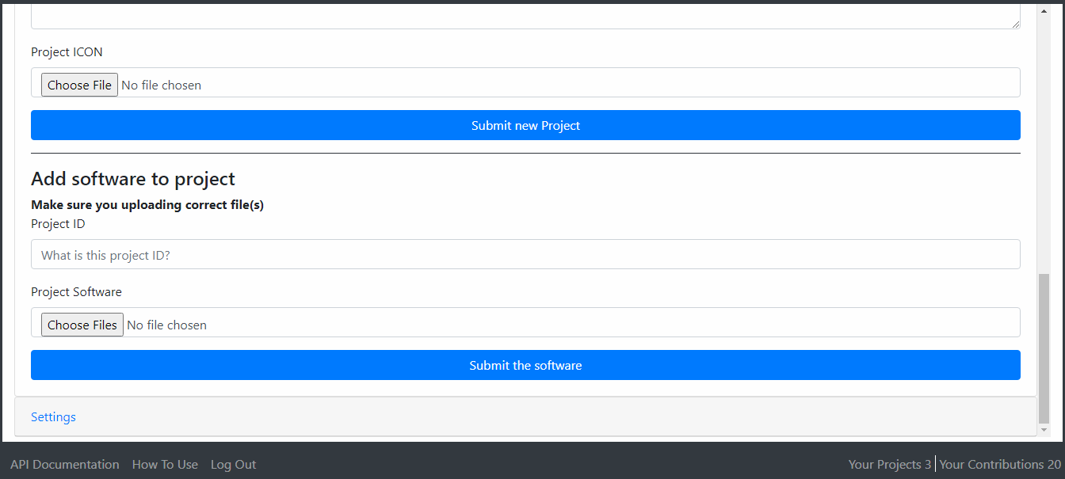

## Settings

Here you can do complete projects, and update your password. When projects achieve the targeted results. Also, in this section you can find your API secret key. These key needs when you develop the client-side software. There are more details about what an API key and how it uses in the API Documentation.

